David Goldstein

National Parks

First of all, there is more than one type of grassland. There are prairies, steppe, and savanna all very diverse from one another, in climate, and in places around the world. For example…

Prairies
Tallgrass Prairie Kansas, USA
Grasslands National Park Montana, USA
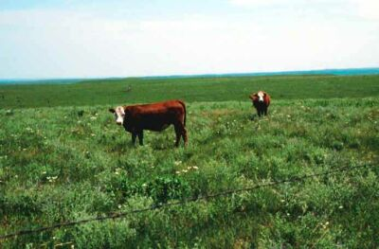
Steppe
Askaniya-Nova Biosphere Reserve, In Ukraine
Yogzat Pinewood Natural Park, Ukraine

Savanna
Gulf savannah, in Australia - Lake Mburo, Uganda 